Christmas
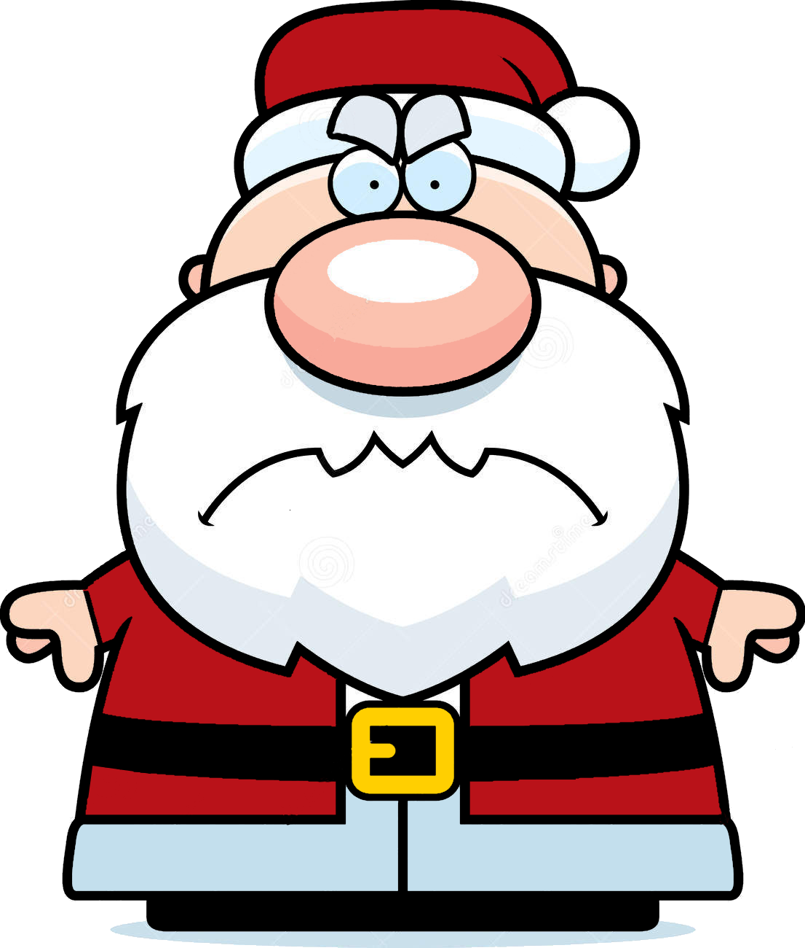
is coming!

My Elves Need
To Get Ready…
And anyone who stacks junk here will get placed on my naughty list!

